5. CUP of KOPER 2018

Invitation to the international Surf ski and SUP race

Dear sport friends,

we invite you to the international Cup of Koper race in surf ski and SUP - downwind categories.

Organizers
Canoe Federation of Slovenia.
Kajak kanu klub Žusterna
and
Kajakaški kanu klub Orka

Date
The race will be held in a window of 2 days, Saturday, 17. 11. 2018 or Sunday, 18.11. 2018 - depending on the best downwind conditions. The exact date will be published 5 days before the race on www.kajak-zveza.si.

Regatta field
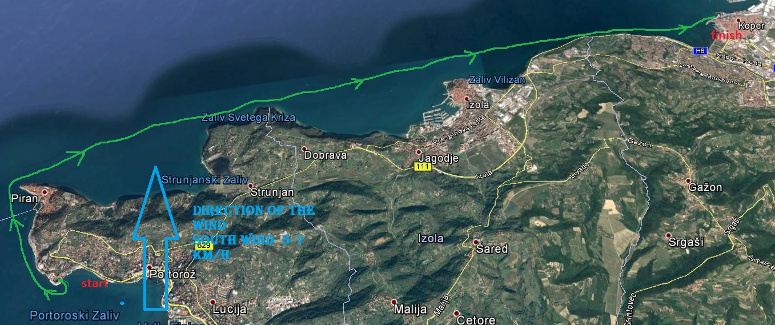

Please note that the race may be organized in one or the other direction. Competitors will be informed about the direction of the race 5 days before the competition.
Start or finish position will be at KKK Žusterna or Bernardin. Start of finish position 2 will be in Bernardin. Start will be from the water. Regatta field is shortest line between Žusterna and Bernardin with a length of approximately
16 km.

Canoes allowed :
All type of kayak boats. Wildwater, sprint, SS1 - Men/Women (open category).
All types of SUPs are allowed (open category).

Categories:
- Juniores, M/W
- Seniores, M/W
- Veterans, M/W

Programme
9.00-10.00 Registration of the competitors, bib and maps delivery at the start.
9.30 Team leaders meeting
11.00 Start of the competition at the KKK Žusterna or Bernardin marina
14.00 Prize giving ceremony at KKK Žusterna

Security and equipment
All participants must declare that they are free of any physical troubles and that they are able to cover high physical demand for about 5 hours. Also every participant must declare that he/she is experienced in paddling at open sea conditions. Every participant has to agree and sign the liability waiver that will be found in the registration.

Safety is guaranteed with 4 boats. All participants have to use their own
equipment, which has to be in secured and fully usable conditions, so it will not become a danger in using it, either for the participants or the organization. Also in addition all participants must have the experience to be able to complete the distance in open sea conditions. The organization reserves the right to deny any participant to start a race, if the organization has the impression or there are obvious signs that either the participant or material is not able to finish the race, without a payback of the registration fee.

The following items are mandatory:
Technically proper equipment. Life vest must be worn. Leash must be worn.
We advise participants to have a GPS and mobile in the water resistant bag.
Very near the start location it will be possible to use the clothes storage and changing room.

Entry fee
Entry fee will be 10 Euros per person.

Medals
Medals will be given to best 3 in each category.

Entries
We ask competitors to contact organizers and make entries before 14. 11. 2018.
via E-mail: jakob.marusic@kajak-zveza.si
or post address:
Kajakaška zveza Slovenije
Celovška 25
1000 Ljubljana
Slovenia

Accommodation and general information
Car parking will be possible near the competition location.
Hot drinks will be available for the competitors near the Start- Finish position.
For accommodation please contact:
T: +386 (0) 5 664 64 03
F: +386 (0) 5 664 64 06
E: tic@koper.si
W: www.koper.si

LEADER OF COMPETITION
Jakob Marušič

